**The Tableau HR Scorecard: Measuring Success In Talent Management**

*1.Introduction:*

**1.1 Overview:**

**The Tableau HR Scorecard is a framework designed to measure and evaluate the success of talent management strategies within an organization. It provides a way for HR professionals and business leaders to track and analyze key performance indicators (KPIs) related to workforce planning, recruitment, retention, and development.**

**1.2 Furpose**

The Tableau HR Scorecard is a framework designed to measure and evaluate the success of talent management strategies within an organization.

1. **Financial Perspective: This perspective focuses on the financial impact of HR initiatives, such as the cost of recruitment, training and development, compensation and benefits, and turnover.**
2. **Customer Perspective: This perspective measures the satisfaction of internal and external customers of HR services, including employees, managers, and job candidates. It includes KPIs such as employee engagement, manager satisfaction with HR support, and candidate experience.**
3. **Internal Process Perspective: This perspective assesses the effectiveness and efficiency of HR processes, such as recruiting, onboarding, performance management, and employee development. It includes KPIs such as time to fill vacancies, time to productivity for new hires, and training hours per employee.**
4. **Learning and Growth Perspective: This perspective evaluates the organization's investment in employee development and its ability to innovate and adapt to changing business needs. It includes KPIs such as employee skills and competencies, employee retention, and the percentage of employees who receive regular training and development.**

**2.Problem statement& Design Thinking:**

**Problem Understanding, also known as Problem Definition or Problem Identification, is the initial and critical phase of any data analysis or problem-solving process. It involves gaining a clear and comprehensive understanding of the problem at hand, its context, scope, and objectives.**

**The business requirement of The Tableau HR Scorecard: Measuring Success in Talent Management is to provide a comprehensive and effective framework for measuring and evaluating the success of talent management strategies within an organization.**

**A literature survey is a method of researching existing literature and studies related to a specific topic. In the context of Measuring Success in Talent Management, a literature survey would involve reviewing studies and articles that have been published on the topic of vehicle collisions.**

1. **Improved employee engagement: The HR Scorecard can help organizations measure and improve employee engagement by providing insights into employee satisfaction, retention rates, and other key metrics. This, in turn, can lead to a more engaged and motivated workforce, which can have a positive impact on productivity and overall business performance.**

**Business Model/Impact**

**Improved HR performance: By tracking and analyzing key HR metrics, The Tableau HR Scorecard can help organizations identify areas where they need to improve and take proactive steps to address them. This, in turn, can lead to improved HR performance, including increased employee engagement, improved retention rates, and enhanced diversity and inclusion efforts.**

**2.1 Empathy Map:**

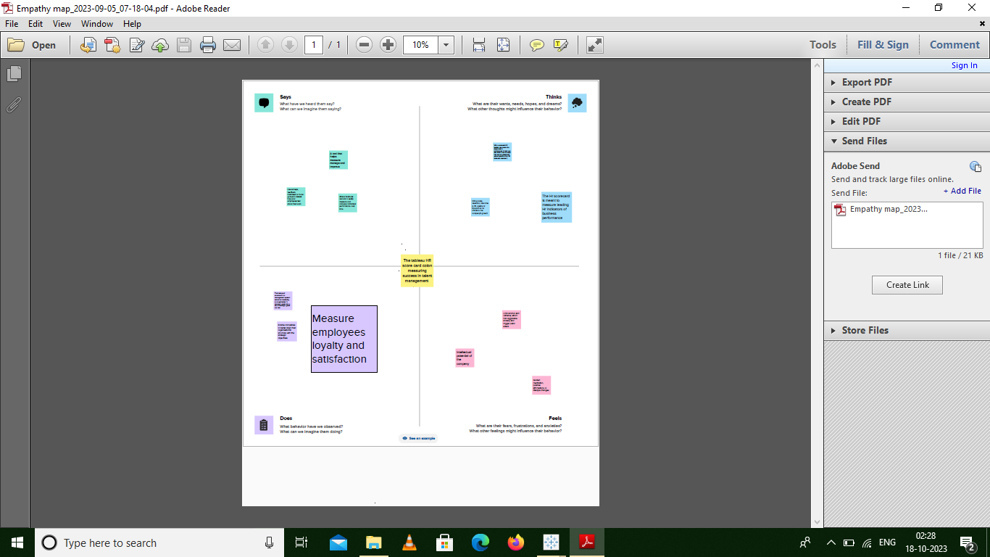

2.2 Ideation and Brainstorming Map:

